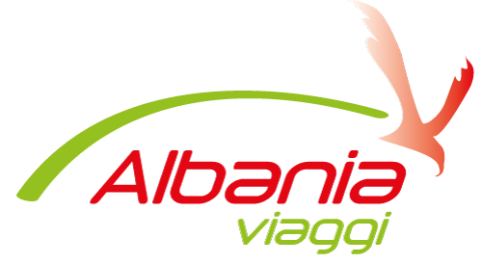

KONTRATE BASHKEPUNIMI SHERBIM TRANSPORTI
Midis
Agjensise Turistike ‘ALBANIA VIAGGI’, me seli ne Orikum - Vlore, Shqiperi, me numer NIPT. L56413201k.
Dhe
Z/Znj…………………………………………, me Numer Licence …………….Data……………….
Lloji Automjetit……………………………………...Targa ……..………………………...…………
Numer vendesh……………………………………...……………………………………...………….
Disponueshmeri zgare siper mjetit……………………………………...……………………………..
Siguracion pasagjeresh……………………………………...………………...……………………….
OFRON CMIMET
Saranda - Tirana Rinas……………………………………...………………………….EURO/LEKE
Saranda - Tirana……………………………………...………………………….……..EURO/LEKE
Sarande - Vlore……………………………………...…………………………………..EURO/LEKE
Sarande - Durres……………………………………...…………………………………EURO/LEKE
Sarande - Shkoder……………………………………...……………………………….EURO/LEKE
Sarande - Gjirokaster……………………………………...…………………………..EURO/LEKE
Sarande - Igoumenitsa……………………………………...…………………………..EURO/LEKE
Sarande - Korce ……………………………………...………………………………EURO/LEKE
Sarande - Permet ……………………………………...………………………………..EURO/LEKE
Sarande - Butrint ……………………………………...………………………………..EURO/LEKE
Sarande - Ksamil ……………………………………...………………………………EURO/LEKE
Sarande – Syri i Kalter ……………………………………...…………………………EURO/LEKE
Sarande - Himare……………………………………...…………………………….EURO/LEKE
Sarande - P. Palermo……………………………………...…………………………EURO/LEKE
Sarande – Ioánnina ……………………………………...……………………………EURO/LEKE

*CMIMI PER CDO ORE PRITJE………………...……………………………………EURO/LEKE
*CMIMI PER KILOMETER TEPER………………...………………………………...EURO/LEKE

ALBANIA VIAGGI
Rr: Princesha Rugjin, Orikum - Albania
Mob: +355 69.96.72.201
Tel: +391.2. 20.66
Email: info@albaniaviaggi.com
Web: www.albaniaviaggi.com

Data, ………………………... Firma ………………………….

